AI ASS 17.1

Name : M.Sanjana
H.T.NO : 2303A52292
Batch No. 43

Task 1:
Prompt: Generate a Python Program for cleaning a customer dataset. That Handles missing values in columns (age, income, city), remove duplicate records, standardize text values (e.g., city names in
lowercase) and encode categorical variables (gender, city).
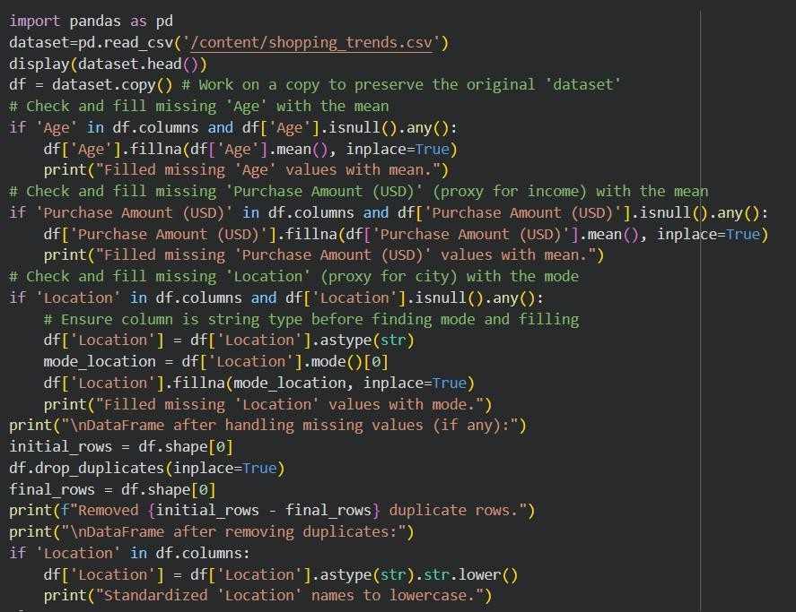
Code:

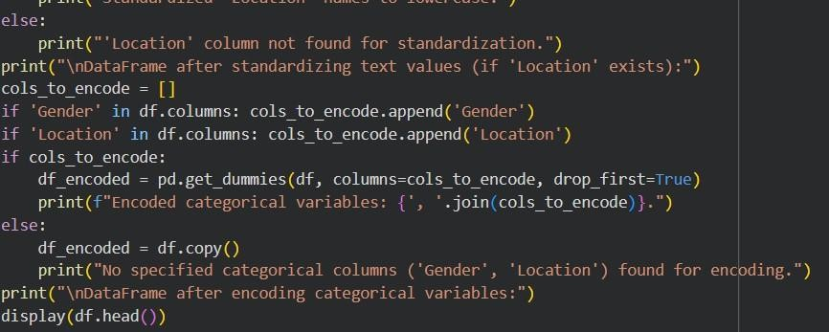
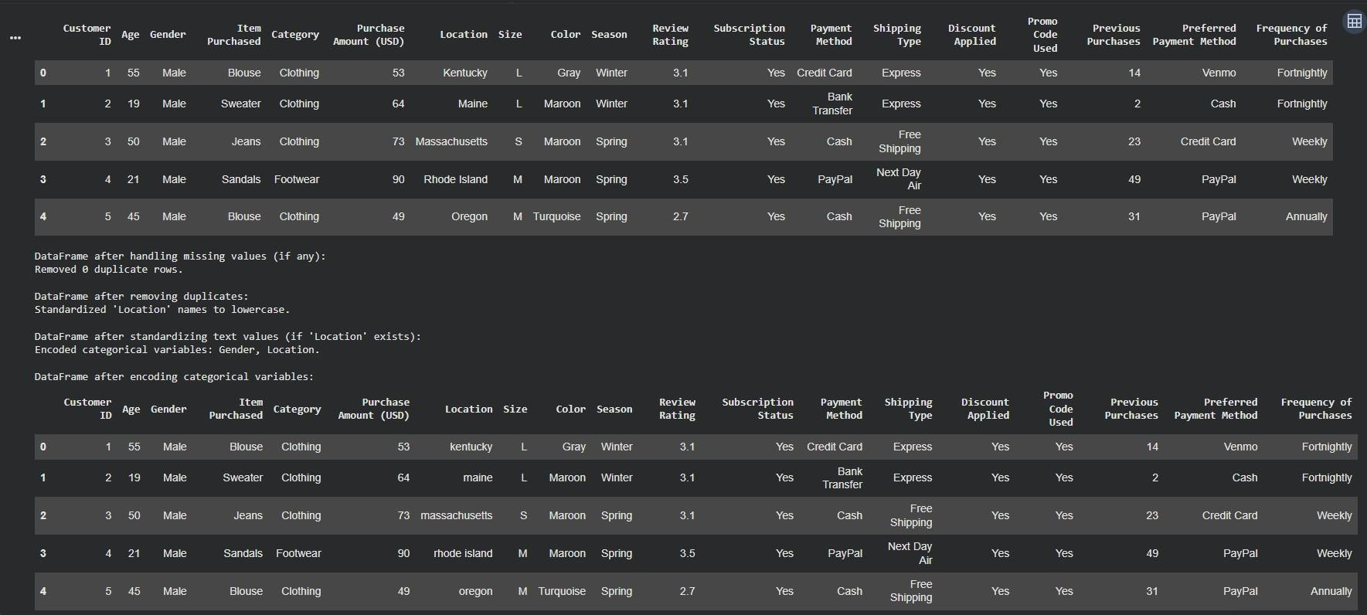
Output:
Explanation:
This program loads your shopping_trends.csv dataset, then cleans it by filling missing 'Age' and 'Purchase Amount (USD)' with their means, and 'Location' with its mode. It removes duplicate rows, standardizes
'Location' names to lowercase, and finally encodes 'Gender' and 'Location' using one-hot encoding for further analysis.

Task 2:
Prompt: Preprocess sales transaction data that Convert date columns into datetime format, create new features (month, year, day of week), normalize sales amount column and detect and handle outliers in dataset.

Code:

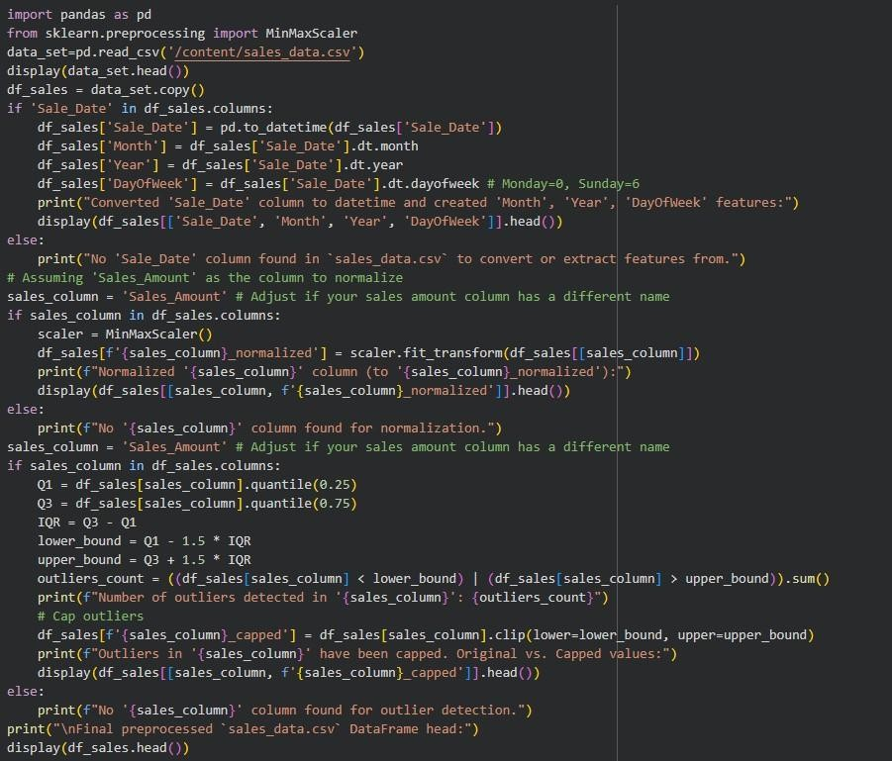
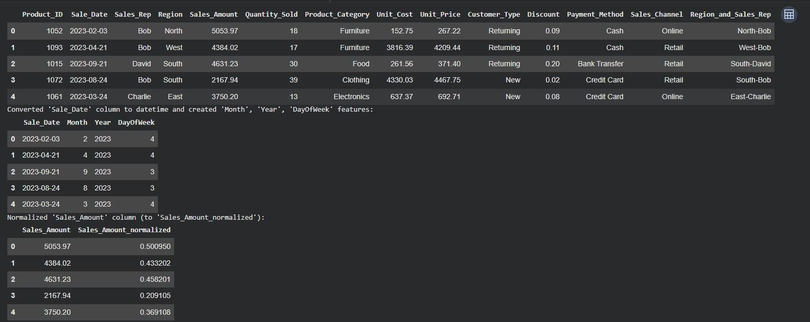
Output:

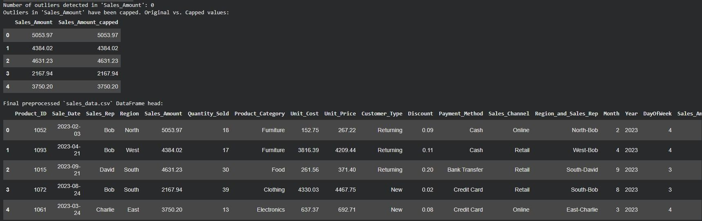
Explanation:
The code preprocessed sales_data.csv. It converted the Sale_Date column datetime, extracting Month, Year, and Day of Week. It then normalized the Sales_Amount column using MinMaxScaler. Task 3: Prompt: Clean and preprocess a healthcare dataset that handles missing values in blood pressure,
cholesterol, encode categorical features, scale numerical features (min-max or standard scaling) and split dataset into training and testing sets.
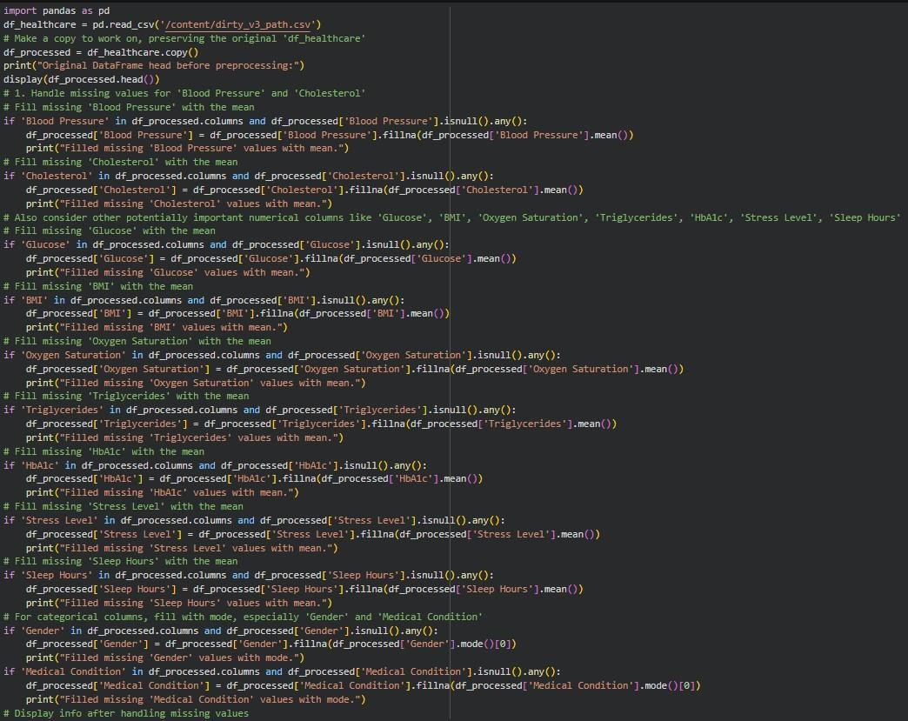
Code:

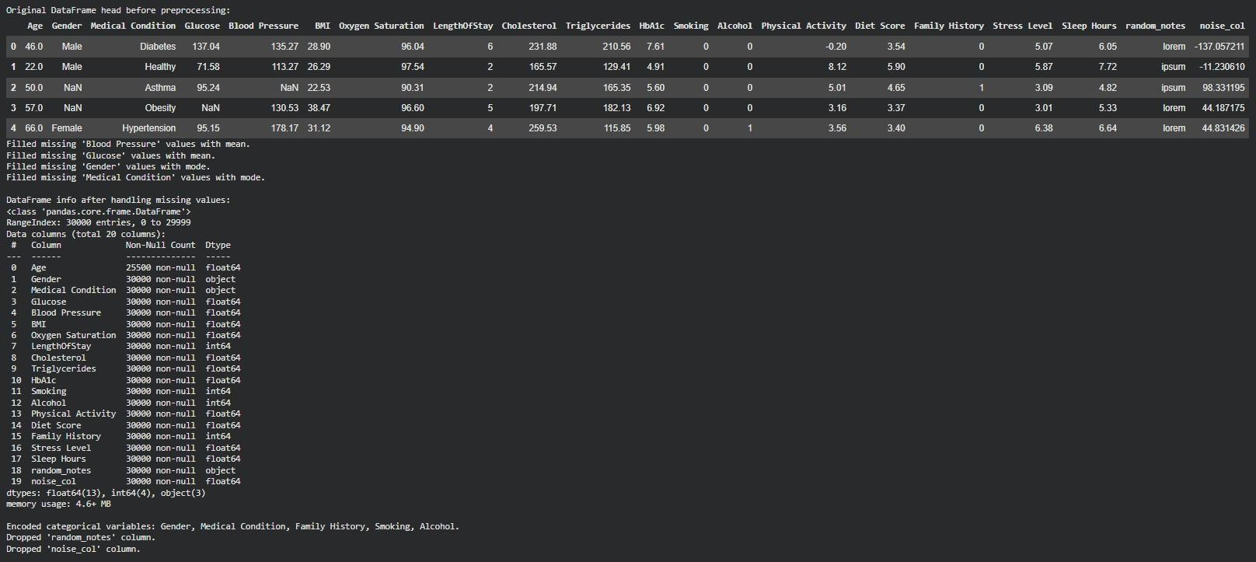
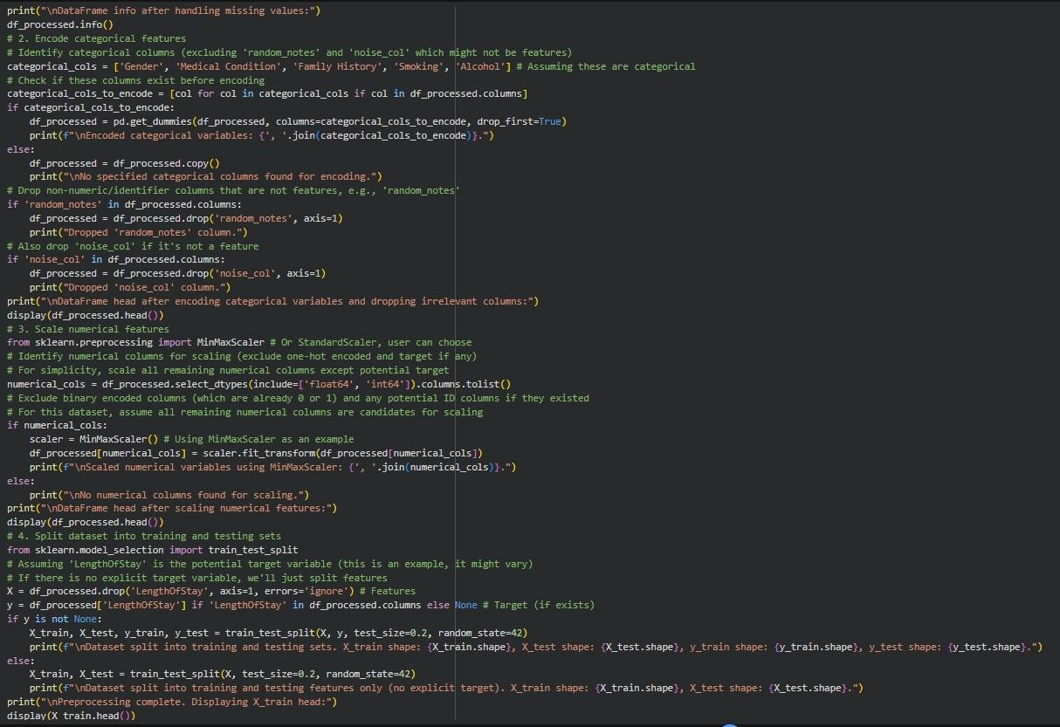
Output:

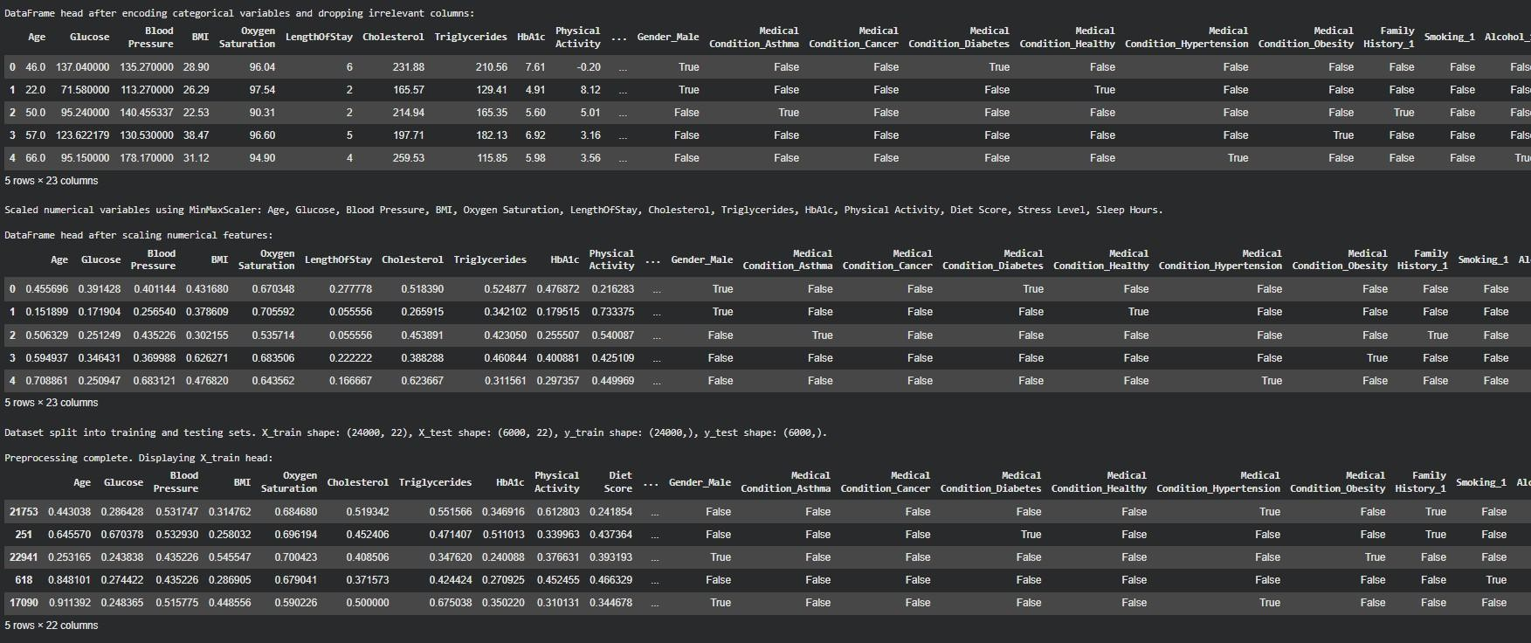
Explanation:
The code preprocesses a healthcare dataset by loading it into a DataFrame, handling missing values using mean/mode imputation, and encoding categorical features. It then drops irrelevant columns and scales numerical features to a 0-1 range. Finally, the prepared data is split into training and testing sets.

Task 4:
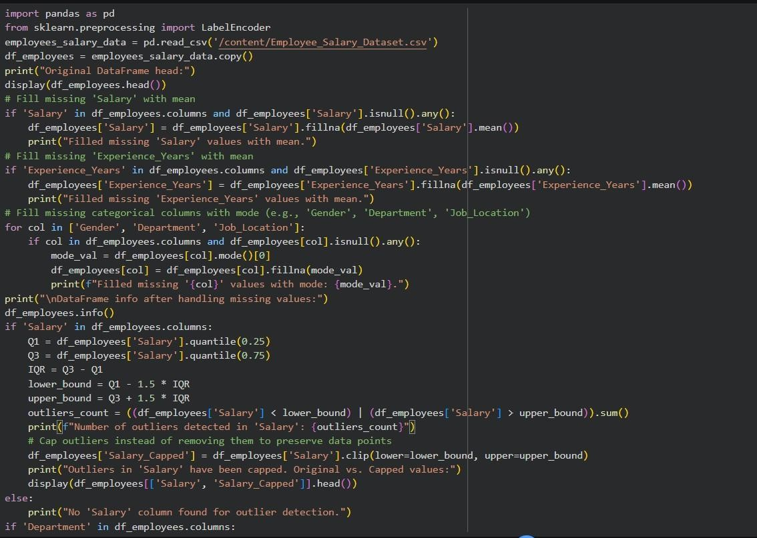
Prompt: Clean and preprocess an employee salary dataset that handles missing values, detect and remove salary outliers, standardize department names (lowercase), apply label encoding to job location, department. Code:

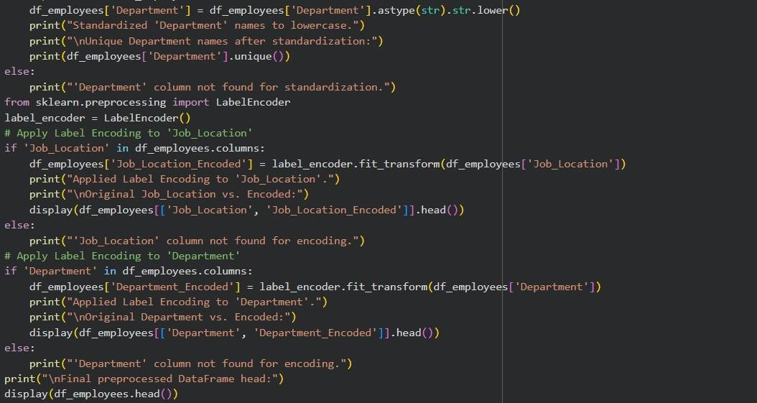
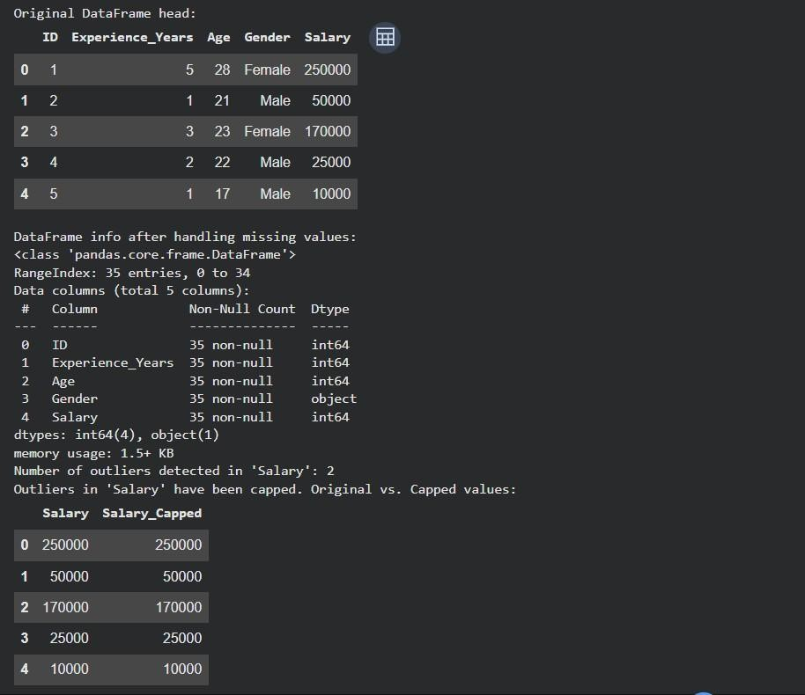
Output:

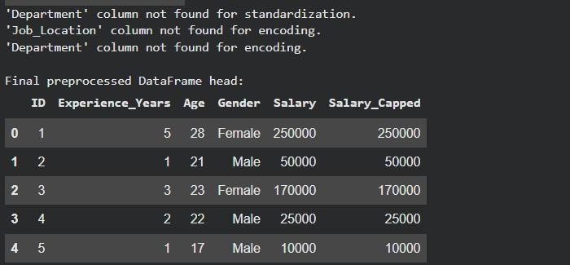
Explanation:
The code preprocesses the Employee_Salary_Dataset. It handles missing values in numerical columns by filling them with the mean, and in categorical columns by filling them with the mode. It then detects and
caps outliers in the 'Salary' column. Finally, it standardizes 'Department' names and apply label encoding to 'Job_Location' and 'Department'.

